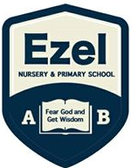 | EZEL NURSERY AND PRIMARY SCHOOL  Home Learning Program  www.ezelschool.com/homelearning.html
Primary Four

Week 1
MONDAY
 | Topics | Activities
Math | - Sets | Activity  - Define a set  - Give examples of sets  Example: a set of 5 mangoes
English | - Practice vocabulary  - Arrange words in alphabetical order | - Vocabulary: good, bad , short , tall  - Activity: Read and spell the vocabulary words.  - Write the words in your books
Literacy | Sight words | under , over , on , in  - Find out the meaning of these words  - Draw a ball on a table  - Draw a box under the table  - Draw a ball over a tree  - A water in a glass
Story  (Reading) | Fruits by Ritah Katetemera  Fruits, fruits, fruits  Fruit is sweet to eat.  People eat different types of fruits.  One may eat mangoes, another may eat pineapples.  We also enjoy oranges. Children enjoy apples. Birds enjoy corn.  Oh fruits are good for health.  People, animals and birds like fruits so much.
TUESDAY
 | Topics | Activities
Math | - Sets | Activity:  - Draw a set of 5 books  - Draw a set of 3 balls  - Draw a set of 7 flowers  - Draw a set of 3 books
English | Using the words correctly. | Activity:  - Sam is near the house (earn)  - Sarah is standing ………….. the table ( no)  - The cup is …………………. the chair (rednu)  - The spoon is …………….. the cup. (ni)  - The bird is flying …………… the tree. (revo)
Literacy | Say out loud the letters, sounds and words | Letter sound: ch  Syllables of sound ch  Cha , che , chi, cho , chu
Reading | “Fruits” - Read the story above
WEDNESDAY
 | Topics | Activities
Math | Naming sets | - Draw a set of 4 balls  - Draw a set of 3 trees  - Draw a set of 5 squares
English | Write the words correctly | Activity: Member of a family.  - Fathre - ………………………………….  - Mthero - …………………………………  - Ssiter - ……………………………………  - Rbother - ………………………………..
Literacy | Drawing | Activity  Draw a boy , girl , father , mother
Story (reading) | “Fruits” - Read the story above
THURSDAY
 | Topics | Activities
Math | Counting elements in a set |   A set of ………………………. circles
English | New words | Activity  Vocabulary: Colour , oval , square , circle
Literacy | Reading and saying sound ‘ch’ | Words beginning with the sound ‘ch’  Church , chat , chalk , chair  Write 3 more words beginning with the sound ‘ch’
Story reading | “Fruits” - Read the story above
FRIDAY
 | Topics | Activities
Math | Sets: Types of sets | - What is a set?  - Name the types of sets that you know
English | -Arrange the words in alphabetical order | Activity: Arrange the words in alphabetical order:  1. circle, square, rectangle, oval  2. road, school, market, bridge  3. short, tall, good, bad  4. Father, brother, sister, mother  5. on, in, under, near
Literacy | Knowing your vowel letters | - Write the 5 vowel letters.  - Write a word for each vowel letter  - Make a sentence using the words you have written.

Note: Dear parents/caregivers always make sure that
- You explain new words to your child.
- Recite new words as many times as you can
- Be kind and patient with your child, they cannot learn new things in one day.
- Provide your child with books, pencils, crayons and papers.

ACTIVITIES
Activity 1 (Language): Read the story and answer the following questions.
Read the story  ‘The Mad Hen’,  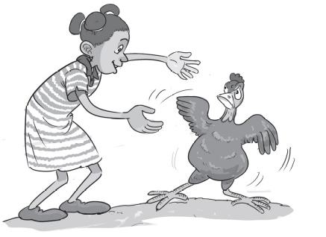 | The red hen was mad. ‘I do not want a hug,’ she said.  A girl ran to the hen. ‘I will give you a hug!’  ‘No,’ said the hen. The hen ran. ‘I am not a pet!’  ‘You are a pet,’ said the girl. ‘I will hug you.’  The girl ran. The hen ran. The girl did not hug the hen.  Answer the questions below.  1. What does the girl want?  2. What happened at the end of the story?  3. How does the hen feel about hugs?  4. What was your favourite part of the story? Why?

Activity 2(Mathematics): Draw the following sets
- A set of 3 trees 4. A set of 2 cups
- A set of 4 balls 5. An empty set
- A set of 6 triangles
Activity 3 (English): Write down the plural of the following words
- loaf –  - Wife –  - Square–  - Sister - | - Brother -  - Baby –  - Chair –  - Knife -

Activity 4(literacy): Draw pictures of the following things
- Table  - Map of Cup  - Chair  - Car | - Hut  - Map of House  - Pot  - Map of tree

Activity 5 (Mathematics): Answer the following additions
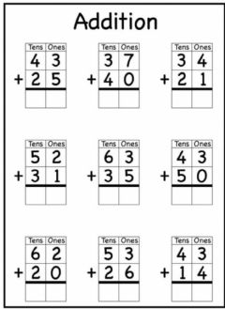

Activity 6 (mathematics): Circle and name all the animals
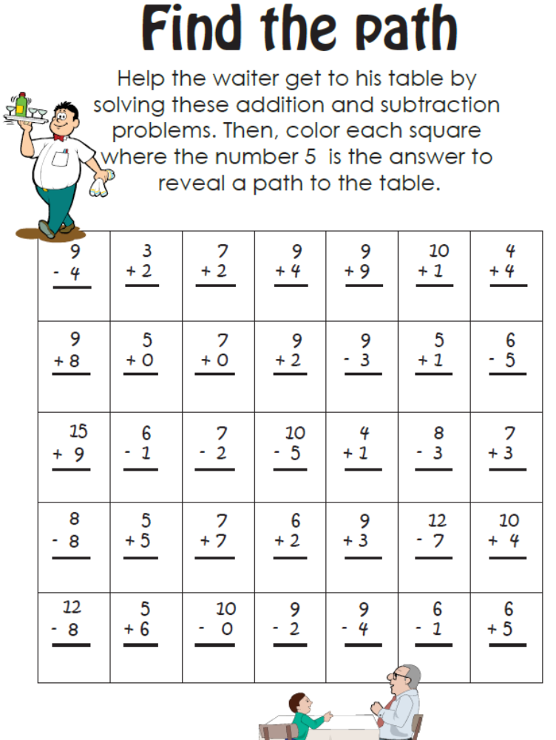

For more information, call
Agule area and all other areas | Kameke Area
0772644523 | 0758650099 | 077074014 | 0786560989 [Director God Help Junior School]

